Import numpy as np

Np. amax(an array)

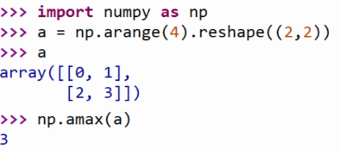

P: don’t use amax for element-wise comparison of 2 arrays;

When a.shape[0] is 2, maximum(a[0], a[1]) is faster than amax(a, axis = 0)

Np. Around(an array,